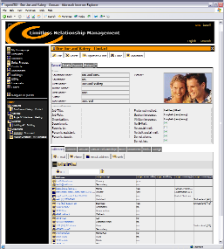

Wednesday, 29 July, 2026

«postalAddressLine»
«postalStreet»
«postalCity», «postalState» «postalCode»
«postalCountry$ShortText»

Primary Phone: «primaryPhone»

openCRX – Limitless Relationship Management

Dear «salutationCode$ShortText» «lastName»:

Please find below the most important benefits of this professional open source CRM solution:
- True Open Source
openCRX is open source software — no hidden agenda, no gimmicks like "patent-pending team-selling features" and no reason to buy a professional/commercial version later to get all the features (because there is no commercial version...) - in addition to the openCRX source code you also get all the UML models and the full Javadoc (everything plublished with a truly open and OSI-certified BSD style license)
- Professional CRM suite — limitless relationship management
powerful and comprehensive best-of-breed features for sales, service, marketing, contact center, and analytics; multi-entity enabled with multi-language and multi-currency support for players in a global market
- Deployment-free client — simply connect with your browser
no need to deploy proprietary clients throughout your organization, openCRX works with any recent version of IE, Opera, Mozilla, Firefox, etc. - try our demo at http://www.opencrx.org/demo.htm
- Easy to integrate and highly interoperable
easy integration with your existing applications (ERP, IVR, CTI, ...) is the best protection for your previous investments and openCRX supports all common technologies like RMI, CORBA, JMS, SOAP, and JCA; openCRX also includes smart front-ends for typical add-ons like document management, inventory tracking, facility management, etc.
- Highly scalable
from a single-user environment on a laptop to enterprise-class globally distributed systems with tens of thousands of concurrent users - openCRX is designed to fit your needs
- Extremely low operations and maintenance costs
open standards, low complexity, highest quality, designed for true 24x7 availability
- Platform-independent and vendor-neutral
openCRX runs on any platform with a J2EE-compliant AppServer (e.g. JBoss, BEA WebLogic or IBM WebSphere) and a major database management system (e.g. MaxDB, MySQL, Firebird, PostgreSQL, MS SQL, Oracle, or IBM DB2).
- Easy to customize
XML-based customization, straight-forward, fast, and flexible (including multi-language features)
- Easy to extend
write your own workflows or develop your own extensions - it's an easy task thanks to openCRX's component-based architecture and open standards like J2EE, MDA, etc.

Regards,

Your openCRX Team http://www.opencrx.org/

