Here is a screen grab history of problems Stylus Studio is having on a Windows XP Pro SP2 IBM laptop:

First, note the .XSD I'm about to open:
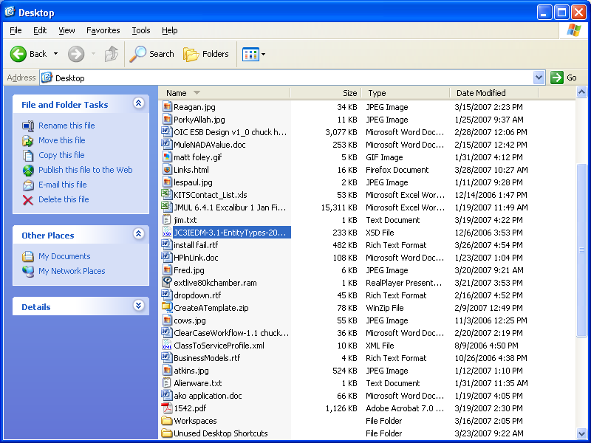

Now, note the error message Stylus Studio presents upon double-click of the .XSD file:
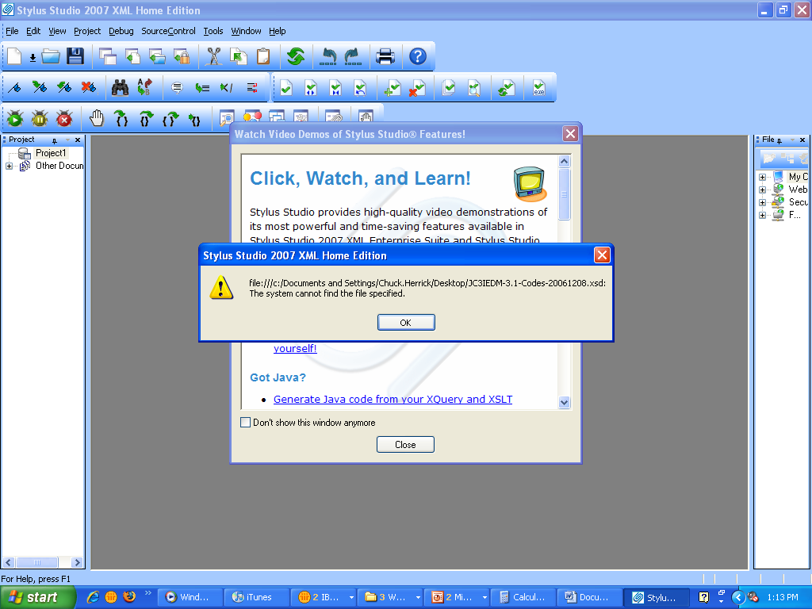

I get the same error when I try to open a file on a network shared drive (this file is local to the machine on which Stylus Studio is installed.

After a long wait, the file is finally opened. If I try this via a file on a network shared drive, Stylus Studio hangs and must be shut down via Task Manager > Kill Application.

What is going on here with Stylus Studio?

Here is the version installed:
