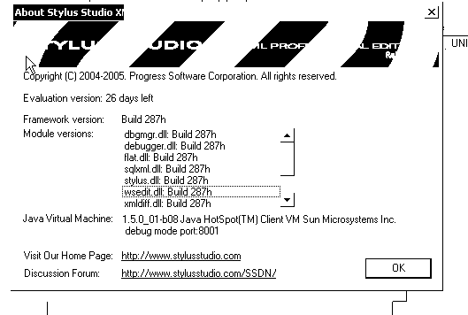

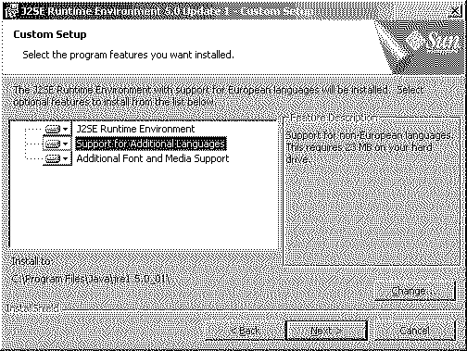

Thanks,
Alex Chua
PC Support Analyst
Unisen Inc.
(905) 214-8127x1010

